Hazard Profiles
Name
Institutional Affiliation

Hazard Profiles
The name of the community is New Orleans and location in Louisiana. New Orleans is one of the most vulnerable cities in terms of climate change due to the fact that it is elevated in a low region, has high rates of land subsidence, the rising of sea levels, as well as predictions of even more powerful hurricanes. According to recent research on climate change in New Orleans, the region is vulnerable to rising sea levels, flooding, and incidences of the storm. According to experts, there is a possibility that the seal levels in New Orleans will rise by 1 to 4.6 feet, depending on the range of estimates of rising sea levels (Weiss et al., 2011). These conditions have resulted in much of the coastal regions in Louisiana to have a high level of sea raise rates, which is considered higher than most in the nation.
The second hazard is flooding and loss of wetland. Based on expert observations, the rise in sea level will defiantly have an impact on the coastal wetlands in the Mississippi area. Without the inclusion of sediments, and an added estimate of wetland will be submerged in water as the twenty-first century ends. In any case, the rise on sea level in these regions is unchecked, New Orleans could, in the end, be in a land that is almost entirely surrounded by open water of the Gulf of Mexico. Reports have described the rate at which Louisiana wetlands disappear at rates nearly close to football fields every hour, and coastal communities are readily washing into the Gulf of Mexico. In addition, losing the coastal wetlands of Louisiana would not simply mean losing natural protection of flood but it would also have an effect on the wide areas involving animals and plants which are supported by the wetlands, most of which are connected with various economic practices such as fishing, tourism, agriculture, timber, and recreation. The overall value of biological productivity and infrastructure associated with wetland regions in Louisiana is costly.
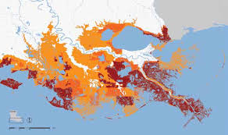
Fig1: Area of possible wetland submersion in New Orleans
Due to the rise of temperatures, the city of New Orleans risks experiencing additionally intense precipitations hurricanes, which makes this the third hazard. The severe rainstorms have resulted in a significant rate of flooding in these regions in the past, and an increase in the intensity of precipitation can so easily worsen the circumstances. Moreover, intense hurricanes could have devastating effects on the city, as seen through Hurricane Katrina. Hurricane Katrina struck on a massive area in the Gulf of Mexico in August 2005, killing nearly 2000 people and damaging up to almost 125 billion dollars in excesses. Louisiana was hit the hardest, with almost 1,500 people died, and most of the New Orleans residents (Garnett & Kouzmin, 2009). The Katrina incident, regarded as Category 3 hurricane, remains the most devastating to the coastal regions that effect can be translated to 50 years of wetland loss based on expert interpretation.
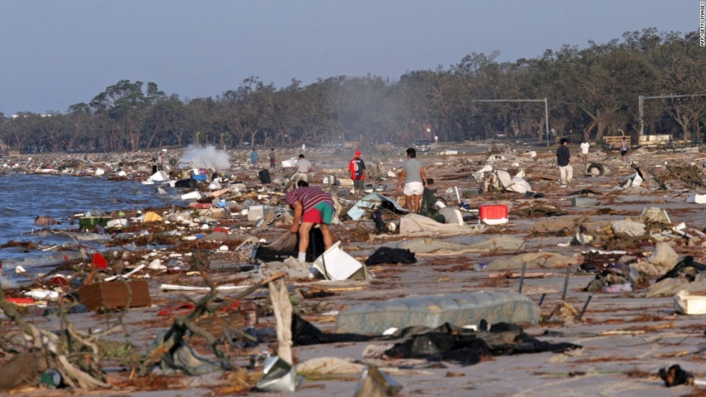
Fig2: Devastating effects of Hurricane Katrina
In Lousiana, New Orleans leads the way in terms of establishing methods that help with the mitigation and adaptation of change on the climate. The incident of Hurricane Katrina and the resulting failures in levee flooded almost eighty percent of New Orleans. The efforts that the city puts in terms of rebuilding focus largely on avoiding a repeat of the disasters and the creation of a more sustainable as well as environmentally conscious surrounding.

References
Garnett, J., & Kouzmin, A. (2009). Crisis communication post Katrina: what are we learning?. Public Organization Review, 9(4), 385.
Weiss, J. L., Overpeck, J. T., & Strauss, B. (2011). Implications of recent sea level rise science for low-elevation areas in coastal cities of the conterminous USA. Climatic Change, 105(3-4), 635-645.

